Ex.no:6 | DATA VISUALIZATION USING POWER BI (ADVANCED SALES ANALYTICS)

Aim:
To Load the data(Retail_sales) into PowerBI and transform the data and visualize it to get insights
Algorithm:
Algorithm 1: Importing Data into Power BI
Step 1
Open Power BI Desktop
Step 2
Select:
Home → Get Data
Step 3
Choose Excel or CSV
Step 4
Browse dataset
Step 5
Click Load
Step 6
Verify imported data

Algorithm 2: Data Transformation using Power Query
Step 1
Select Transform Data
Step 2
Open Power Query Editor
Step 3
Remove duplicates
Step 4
Handle null values (replace blanks/nulls in columns like CustomerName and Discount)
Step 5
Rename columns & format text casing (e.g., Capitalize Region)
Step 6
Apply changes & Close

Algorithm 3: Advanced Transformations & Date Parsing
Step 1
Select OrderDate column and ensure data type is set to Text
Step 2
Go to Add Column → Custom Column
Step 3
Name column: ParsedDate
Step 4
Apply Power Query M Formula:
Code snippet
if Text.StartsWith([OrderDate], "2025-") then
Date.FromText([OrderDate])
else if Text.Contains([OrderDate], "/") then
Date.FromText([OrderDate], [Format = "dd/MM/yyyy", Culture = "en-GB"])
else
Date.FromText([OrderDate], [Format = "MM-dd-yyyy", Culture = "en-US"])

Step 5
Handle negative quantities (Absolute Value or filter rows)
Step 6
Click Close & Apply to load the clean dataset into the model

Algorithm 4: Creating Calculated Column (Revenue)
Step 1
Navigate to Report View or Table View
Step 2
Right-click dataset table and select New Column
Step 3
Enter Revenue formula:
$$\text{Revenue}=\left[Quantity\right]×\left[UnitPrice\right]×\left(1-\left(\text{if }\left[Discount\right]=\text{null then }0\text{ else }\left[Discount\right]\right)\right)$$
Step 4
Press Enter to validate and compute values
Algorithm 5: Dashboard Visualization & Reporting
Step 1
Select Line Chart visualization and map ParsedDate (X-axis) and Revenue (Y-axis)
Step 2
Select Bar / Column Chart and map Region (X-axis) and Revenue / Quantity (Y-axis)
Step 3
Select Donut Chart to break down quantities by Product
Step 4
Add Slicer visuals for Region and Date to enable interactive filtering
Step 5
Save the Power BI file (.pbix)
Output:
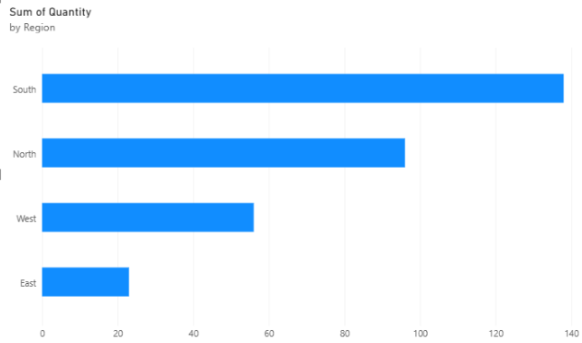

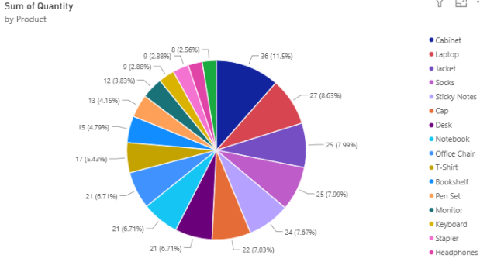

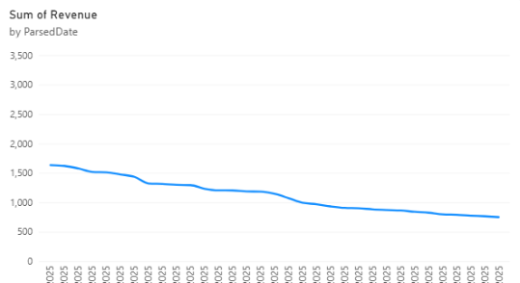

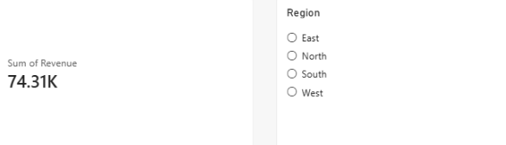

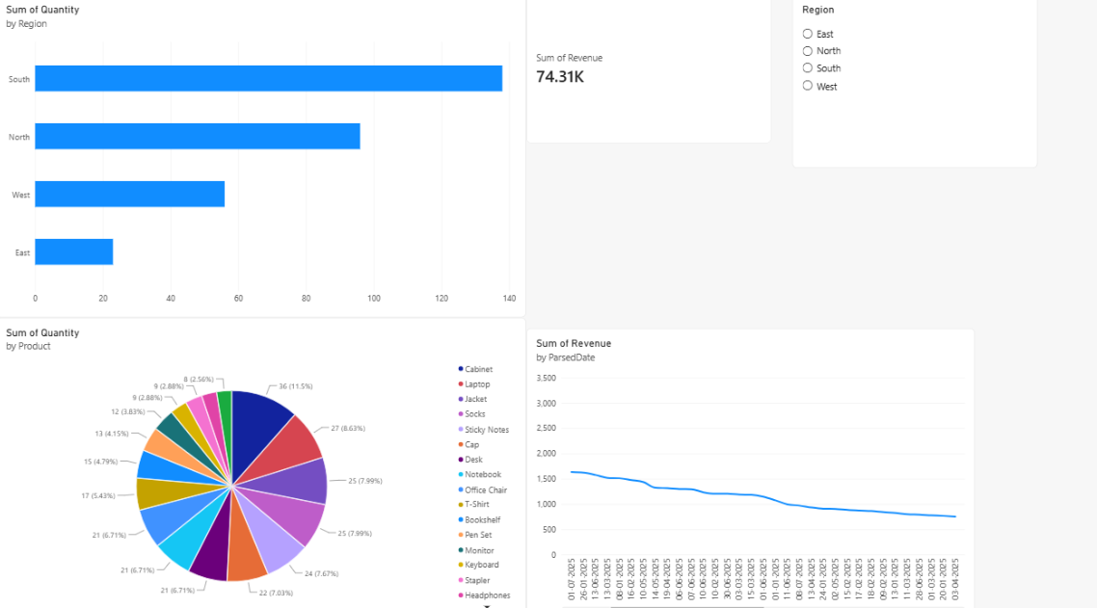

Result:

